Progress by consultation date
Date | Summary
27 September 2026 — First checkpoint | To Be Confirmed. No dated development evidence establishes what was completed before this consultation.
4 October 2026 — Second checkpoint | To Be Confirmed. Checkpoint-specific accomplishments need supporting records.
11 October 2026 — Third checkpoint | Connected database, authentication, property/tenant management, OCR, billing, corrections, payments, receipts, and tenant portal. 25 tests passed. The records do not confirm whether verification finished before the consultation.
12 October 2026 — After the third checkpoint | Repository changes address manuscript alignment, explicit Manager advance approval, mobile/local-network guidance, and payment-policy revisions. These changes were inspected but need fresh testing.
Remaining priorities: live email intake, real background push delivery, representative utility-document testing, paid-bill corrections, reminder timing, and alignment with the approved manuscript.

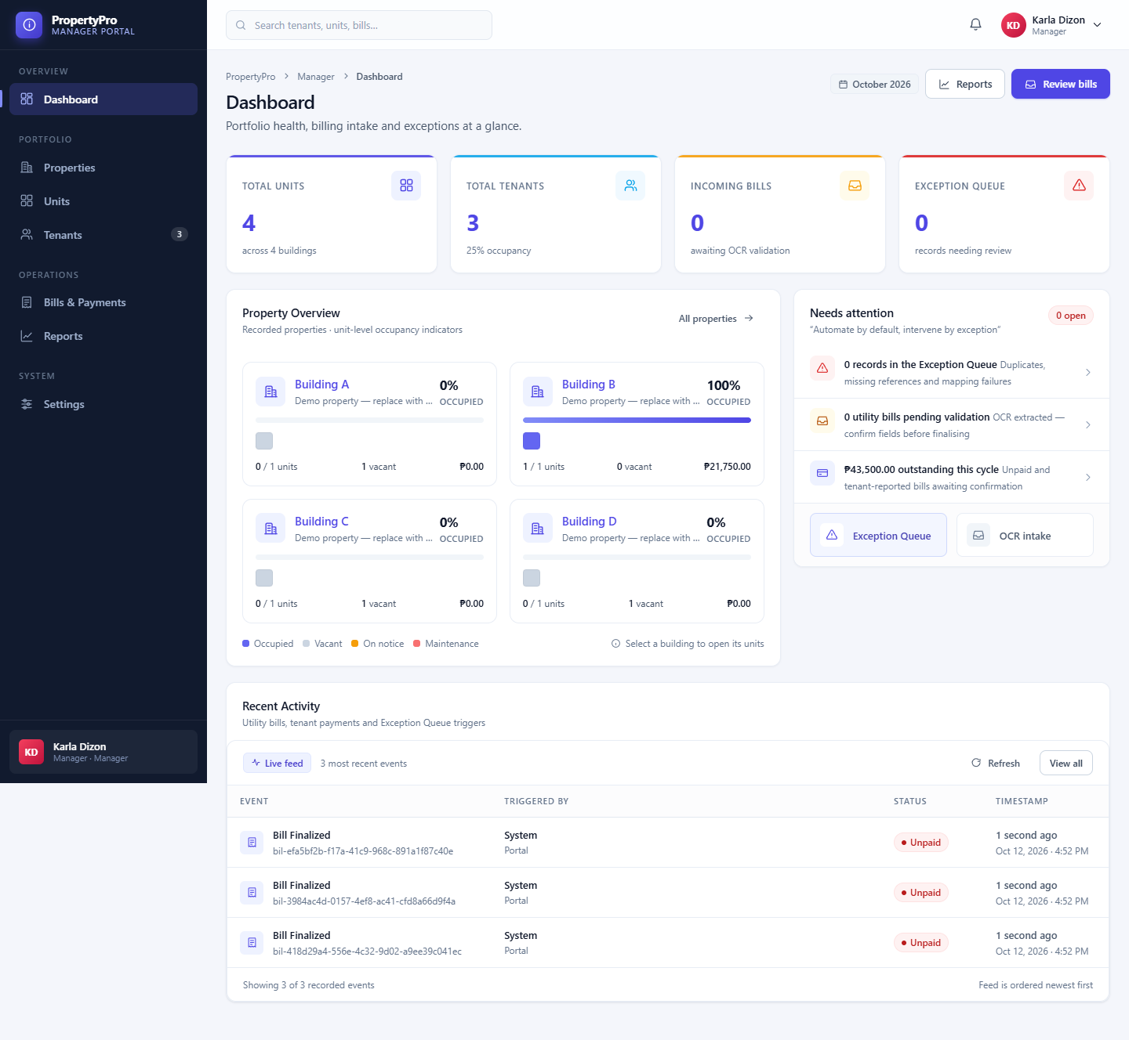
Mock up Designs
Manager Dashboard

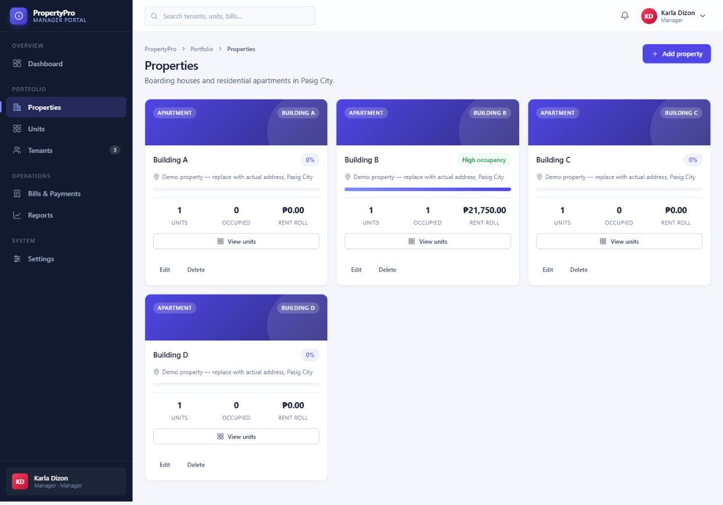
Property management ( manager )
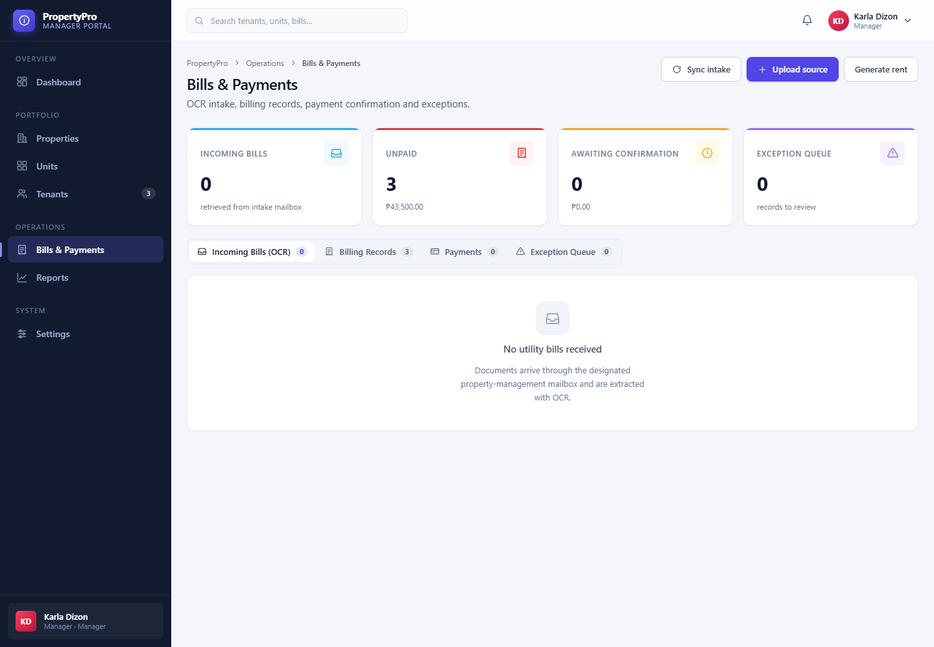
Bills and payments

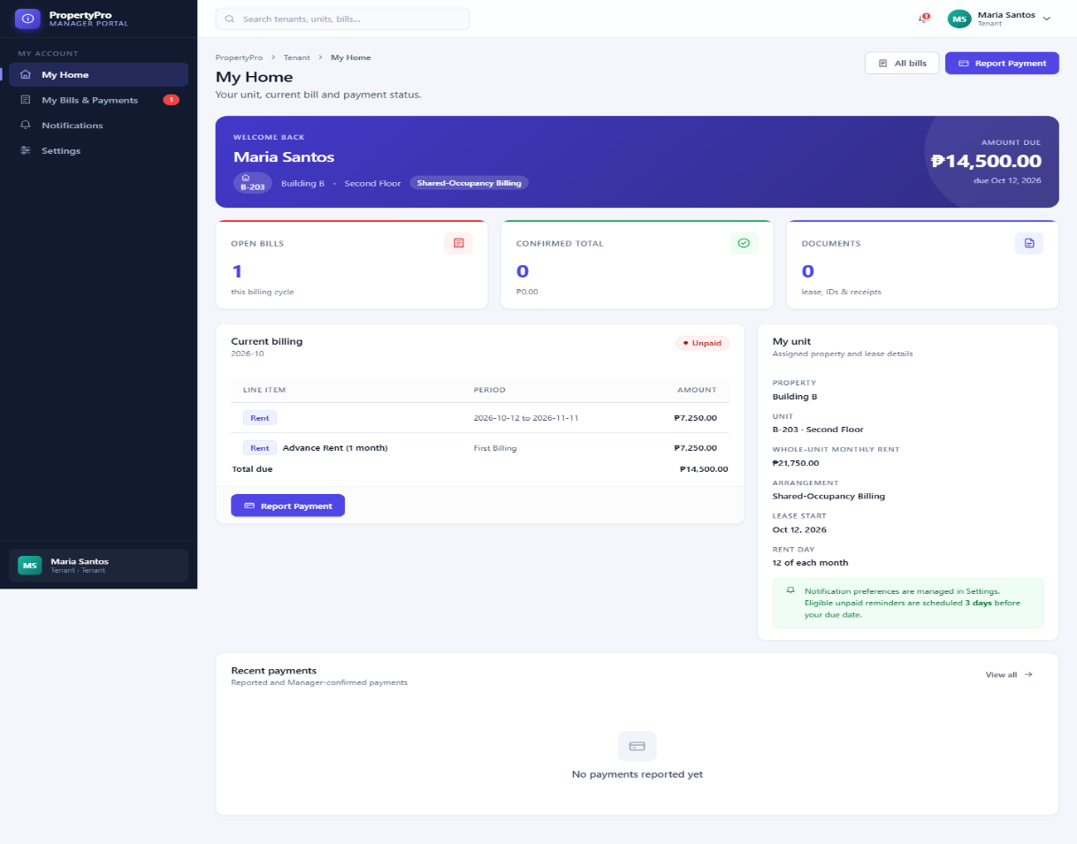
Tenant Dashboard

Admin Dashboard
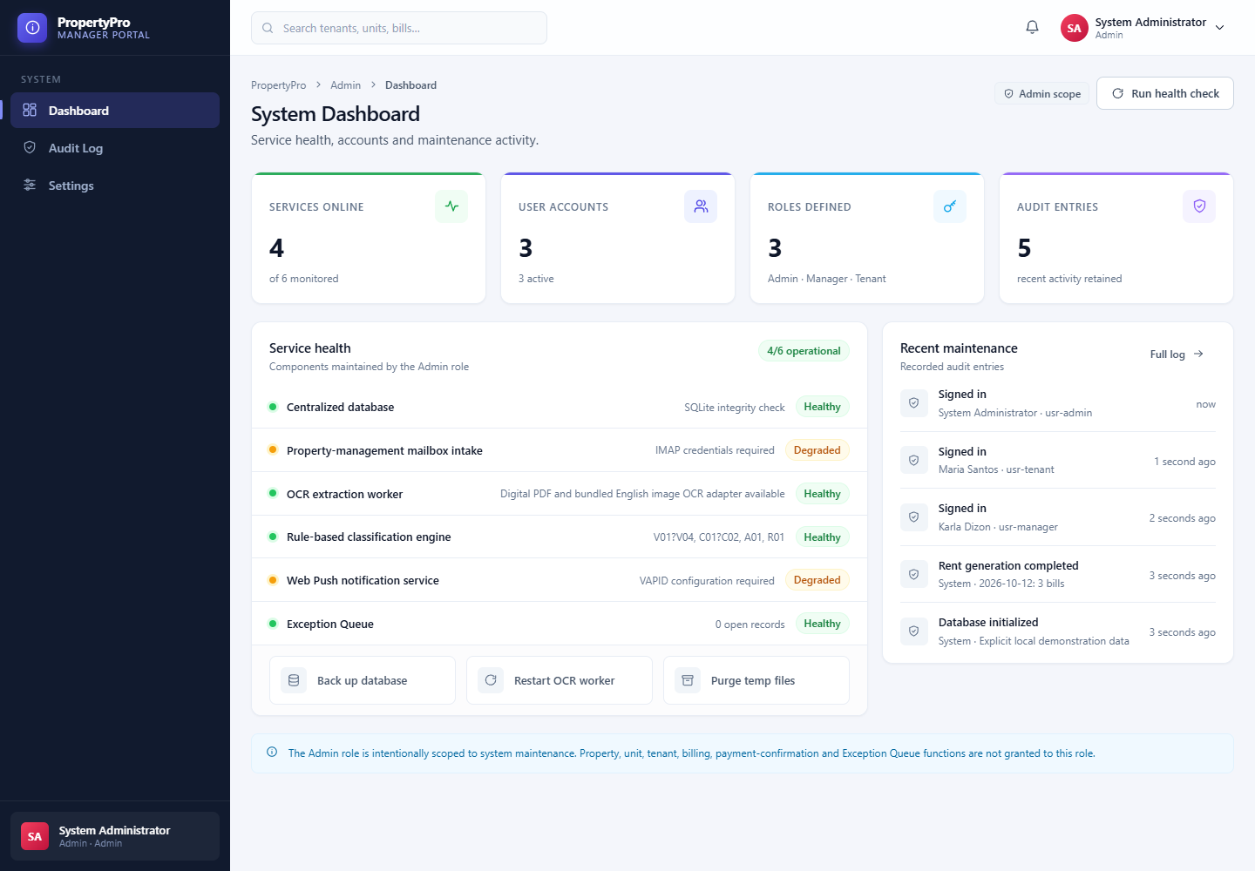

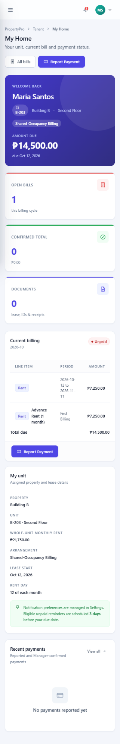
Tenant Mobile website

